CHAPTER ONE
INTRODUCTION
1.1 Background of Study
In the contemporary global educational landscape, the integration of digital communication tools has transitioned from a supplemental luxury to a fundamental infrastructure necessity. This shift is not merely a byproduct of technological advancement but a strategic response to the evolving nature of information consumption among digital natives a generation of learners who prioritize instantaneous, interactive, and collaborative access to knowledge. The rapid digitization of higher education, significantly accelerated by the global shifts toward blended and remote learning, has necessitated the creation of dedicated, high-integrity spaces for asynchronous academic discourse. Unlike synchronous classroom sessions, these platforms allow for deep reflection, permanent documentation of ideas, and inclusive participation that transcends physical and temporal boundaries.
According to Garrison, Anderson, and Archer (2010), an Academic Discussion Forum is defined as a digital Community of Inquiry that facilitates the construction of knowledge through purposeful and collaborative dialogue. Unlike generic social media, an academic forum is characterized by its pedagogical structure, where discussions are organized into threads that allow students to engage in Co-operative Learning. Thomas (2021) further clarifies that these forums serve as the primary vehicle for asynchronous interaction, providing a sanctuary for students to test hypotheses, seek clarification on complex course modules, and engage in peer-to-peer tutoring. In the context of a University environment, such a forum acts as a digital extension of the laboratory or lecture hall, ensuring that the intellectual pulse of the faculty remains active twenty-four hours a day.
An examination of the current state of academic discourse platforms reveals a significant technological and engagement-based transition. Traditionally, academic discussion has been hosted within standard Learning Management Systems (LMS) such as Moodle, Canvas, or Blackboard. However, research by Olayinka and Adebayo (2023) suggests that the Traditional State of these forums is often characterized by Systemic Rigidity. Students frequently perceive LMS-based forums as bureaucratic and unengaging, leading to low participation rates and a lack of organic knowledge sharing.
In response to this, the Emerging State of campus communication in many developing regions, particularly Nigeria, has seen a massive migration toward unmoderated third-party mobile applications like WhatsApp and Telegram. While these platforms offer high engagement and ease of use, they represent a Chaotic State of information management. Okonkwo (2022) identifies that these informal apps lack the hierarchical organization, searchability, and moderation protocols required for serious academic scholarship. Consequently, the global Future State of educational technology is now moving toward Intelligent Community Platforms. These are systems that utilize Artificial Intelligence (AI) and Natural Language Processing (NLP) to automate the moderation process, categorize content by discipline, and provide real-time sentiment feedback to maintain a professional atmosphere. This transition from manual, human-dependent gatekeeping to autonomous, AI-driven moderation is the specific technological frontier explored in this research.
In the Nigerian context, the push for digital transformation is met with unique infrastructural and socio-cultural challenges. Many universities continue to struggle with high data costs and unreliable external internet access, which significantly limits the student's ability to remain always-on in a cloud-dependent environment. As noted by Adebisi (2021), there is a documented need for Localized Cloud solutions technological artifacts that can reside within a University’s Local Area Network (LAN) to provide high-speed, zero-data-cost access to academic resources.
However, many institutions still rely on off-the-shelf global solutions that do not account for these local bandwidth constraints or the specific administrative hierarchies found in Nigerian faculties. There is a palpable disconnect between the advanced features available on international platforms and the practical, accessible needs of a local campus community. This gap necessitates a specialized approach to system design one that combines the intelligence of modern AI with the efficiency of a localized, faculty-segregated architecture.
Consequently, this research focuses on the Design and Implementation of an Intelligent Academic Discussion Forum specifically for the Faculty of Computing. By targeting this specific academic body, the project addresses the needs of a highly technical and tech-savvy user base that requires a robust, structured, and moderated environment for code-sharing, logic-debating, and peer-to-peer mentorship.
This platform, hereafter referred to as the UNIDEL FORUM, is not merely a communication tool but a sophisticated sociotechnical system designed to foster a Community of Practice. By leveraging Artificial Intelligence (AI) and the MERN stack (MongoDB, Express, React, Node.js) alongside a relational MySQL database, the system aims to automate the moderation of toxic content and ensure that the digital halls of the Faculty remain a safe, professional, and intellectually stimulating environment. This localized solution represents a significant advancement in how the University of Delta can utilize its existing LAN infrastructure to support the next generation of computing professionals.
1.2 Statement of the Problem
Despite the growing integration of digital tools at the University of Delta, there remains a significant gap between the availability of technology and its actual academic utility within the Faculty of Computing. As identified in the review of literature, the current state of academic discourse is hindered by three core systemic failures:
- The Rigidity of Traditional Learning Management Systems (LMS): As discussed in the literature regarding Systemic Formality, traditional platforms like Moodle and Canvas are often perceived by students as Digital File Cabinets. These systems facilitate the unidirectional download of resources but fail to foster the vibrant, peer-to-peer interaction required for a true Community of Practice (Wenger, 1998). This lack of engagement creates a high Transactional Distance (Moore, 1993), leaving students feeling isolated from their instructors and peers.
- The Chaos and Persistence Failure of Informal Platforms: In response to the rigidity of formal systems, students have migrated to informal apps like WhatsApp and Telegram. However, as noted by Anderson (2021), unmoderated digital spaces frequently devolve into Echo Chambers where academic quality is sacrificed for social chatter. These platforms suffer from a total lack of organizational hierarchy and automated moderation, turning vital academic discussions into Information Graveyards where knowledge is buried and lost almost instantly. This Zero-Governance environment makes it impossible for students to archive or search for critical course concepts, leading to significant Information Fatigue.
- The Economic Barrier of the Digital Divide: The literature highlights a unique Digital Divide in the Nigerian educational landscape, where the high cost of data and unreliable ISP infrastructure prevent students from staying always-on in cloud-dependent environments. Without a Localized Cloud solution that can run on the university’s Local Area Network (LAN), students with limited financial resources are effectively excluded from the university's digital academic life.
These literature-identified gaps Pedagogical Isolation, Operational Chaos, and the Economic Divide collectively hinder the academic development of computing students. Without an intelligent, faculty-segregated forum that provides automated moderation and zero-cost LAN access, the University of Delta community will remain dependent on fragmented, high-risk communication channels that do not uphold the rigour of professional scholarship.
1.3 Aim and Objectives
The primary aim of this research is to develop a smart, faculty-segregated web application that serves as a professional repository for academic discourse. The project seeks to bridge the communication gap between students and instructors by leveraging Artificial Intelligence to maintain a safe, productive, and intellectually stimulating digital environment.
To achieve the aforementioned aim, the following specific objectives will be pursued:
- To design a responsive user interface using React.js and a three-tier system architecture that facilitates structured, threaded discussions within specific faculty boards.
- To implement an intelligent moderation middleware powered by Natural Language Processing (NLP) to autonomously identify, score, and filter toxic or non-academic content.
- To implement a robust relational database using MySQL (via XAMPP) for the secure and persistent storage of student profiles, academic threads, and reputation metrics.
- To implement a gamified reputation system featuring verified badges and upvotes to incentivize high-quality peer-to-peer tutoring and increase student engagement.
- To evaluate the functionality, speed, and reliability of the integrated platform over a Local Area Network (LAN) to ensure high-speed accessibility for the UNIDEL community.

1.4 Significance of the Study
The significance of this study lies in its multi-dimensional approach to institutionalizing digital discourse within the Faculty of Computing at the University of Delta. By providing a permanent, searchable Knowledge Bank, the research prevents the Information Decay common in informal applications, preserving critical technical discussions and code-sharing sessions. This is further enhanced by a Reputation System that establishes a measurable metric for student expertise and collaborative excellence.
Furthermore, the project introduces Administrative Offloading through intelligent automation. By utilizing Natural Language Processing (NLP) for autonomous moderation, the study demonstrates how the university can maintain a professional digital environment without the unsustainable burden of manual monitoring, thereby upholding the institutional integrity of the university's digital halls.
Finally, this research represents a strategic step toward a Smart Campus ecosystem by championing a Local Cloud model. Operating via the campus Local Area Network (LAN) ensures zero-data-cost access, effectively bridging the Digital Divide for students with limited financial resources. Ultimately, this project provides a scalable blueprint for localized, intelligent communication that can be adopted across various faculties within the institution.
1.5 Scope of the Study
The scope of this research is specifically centered on the Faculty of Computing at the University of Delta, Agbor, which serves as the primary case study for the implementation and testing of the intelligent forum. The study focuses on the technical development of a hybrid architectural model, integrating the MERN stack (MongoDB, Express, React, and Node.js) for dynamic application logic with a MySQL relational database for secure data persistence. This focus includes the implementation of core intelligent features such as automated moderation through Natural Language Processing (NLP) and a gamified reputation system. The method of deployment is strictly restricted to the university's Local Area Network (LAN) via local IP binding. This approach ensures high-speed, zero-data-cost access for the UNIDEL community, prioritizing localized network utility over global internet hosting to bridge the digital divide within the campus environment.
1.6 Limitations of the Study
While this study provides a robust framework for intelligent academic discourse, certain limitations must be acknowledged:
Simulated Server Environment: The performance and scalability of the forum are evaluated within a controlled, local server environment. Consequently, the system’s behavior under extreme concurrent traffic (thousands of simultaneous requests) or on high-end enterprise-grade hardware remains outside the scope of this initial prototype testing.
Linguistic Constraints of the NLP Engine: The intelligent moderation system is primarily trained on standard English datasets. Therefore, its ability to accurately detect toxicity or sentiment in highly localized slang, Pidgin English, or technical abbreviations specific to the Nigerian campus context may be limited by the existing natural language processing libraries used.
Behavioral Variables in User Adoption: The success of the Reputation System and the Verified Badge logic is dependent on consistent user participation. The study’s evaluation of these features relies on behavioral models and feedback from a pilot group within the Faculty of Computing, which may not fully represent the long-term interaction patterns of a larger, more diverse university population.
1.7 Conceptual Clarification
To ensure a common understanding of the specialized terminology used throughout this research, the following concepts are clarified:
Intelligent Moderation: This refers to the deployment of Natural Language Processing (NLP) algorithms that act as a digital gatekeeper. Unlike traditional keyword-blocking, this concept involves analyzing the sentiment and toxicity of text to make nuanced, automated decisions on whether a post aligns with academic standards.
Faculty Segregation: This is an architectural design pattern where the user experience is gated based on institutional identity. It ensures that students are automatically routed to digital boards relevant to their specific department (e.g., Computer Science, Cyber Security), preventing information overload and ensuring the relevance of the academic discourse.
MERN-Relational Hybrid: A specific development approach used in this project that combines the flexibility of NoSQL (MongoDB) for unstructured posts with the strict integrity of SQL (MySQL) for sensitive user matriculation data.
1.8 Operational Definition of Terms
To ensure clarity for all readers, including those outside the immediate field of software engineering, the following technical and operational terms are defined as they are used in the context of this study:
MERN Stack: An acronym for a collection of four key technologies (MongoDB, Express, React, and Node.js) that allow for full-stack JavaScript development. In this project, it facilitates the high-speed interaction required for a real-time forum.
XAMPP: A cross-platform web server solution stack consisting of Apache, MariaDB (MySQL), PHP, and Perl. In this research, it is utilized as the hosting environment for the MySQL database on a local machine to simulate a campus server.
Sentiment Score: A numerical metric generated by the Natural Language Processing (NLP) middleware. This score represents the emotional temperature or toxicity level of a post, allowing the system to make autonomous moderation decisions.
Asynchronous Communication: A method of interaction where participants do not need to be online simultaneously. This is the primary mode of the UNIDEL Forum, allowing for reflective and deep-dive academic discussions.
Relational Integrity: Refers to the consistency and accuracy of data within the MySQL database, ensuring that student profiles are correctly linked to their respective posts and reputation scores.

1.9 Organization of Other Chapters
The remainder of this project is structured into four distinct chapters, each contributing to a comprehensive understanding of the research:
Chapter Two: Literature Review provides a scholarly examination of existing digital learning theories, explores related works in the EdTech space, and identifies the current research gaps that the UNIDEL Forum seeks to fill.
Chapter Three: System Analysis and Design details the methodology used to analyze the user requirements and provides the technical blueprints (Use Case diagrams, Sequence diagrams, and Flowcharts) for the platform’s construction.
Chapter Four: System Implementation and Evaluation discusses the actual coding process, the deployment of the AI middleware, and the results of the testing phase, including user feedback and performance metrics.
Chapter Five: Summary, Conclusion, and Recommendations provides a final synthesis of the project findings, offers strategic advice for the University of Delta administration, and suggests paths for future research in autonomous academic moderation.

CHAPTER TWO
LITERATURE REVIEW
2.1 Introduction
The literature review serves as the critical theoretical foundation for this research, providing a scholarly examination of the technologies and pedagogical frameworks that underpin modern digital learning. The primary subject of this study is the Academic Discussion Forum, a specialized sociotechnical system engineered to facilitate high-integrity, asynchronous knowledge exchange. In the specialized context of the Faculty of Computing at the University of Delta (UNIDEL), this subject represents more than a mere communication utility; it is a strategic infrastructure designed to capture and preserve Tacit Knowledge the informal, expert-level insights shared between students and instructors during the problem-solving process.
Historically, academic communication has transitioned through several distinct phases. It began with the traditional Physical State, where scholarly discourse was confined to face-to-face interactions within lecture halls. With the advent of the internet, this shifted to a Static Digital State, characterized by basic bulletin boards and email lists. However, as the educational landscape has become increasingly digitized, there is a burgeoning need for an Intelligent State of communication. This subject the Intelligent Forum addresses the modern challenges of information overload and digital noise. By integrating Artificial Intelligence (AI) and Natural Language Processing (NLP) into the core architecture, the subject of this study moves beyond passive data storage to active, autonomous moderation.
Furthermore, the study explores the subject through the lens of localized utility. While global platforms offer generalized features, this research focuses on the Localized Cloud model, which adapts to the specific infrastructural constraints of the Nigerian university system, such as high data costs and bandwidth limitations. This chapter will critically analyze existing literature regarding Virtual Learning Environments (VLEs), the psychological impact of Transactional Distance, and the technical superiority of the MERN stack in building real-time, responsive educational tools. By synthesizing these diverse academic threads, the review establishes a clear justification for the UNIDEL Forum as a necessary evolution in campus-based digital collaboration, ensuring that the digital halls of the Faculty remain a productive sanctum for academic growth.
2.2 Conceptual Framework
The conceptual framework for this study is built upon a tripartite relationship between digital interaction, academic outcomes, and automated governance. This framework serves as a map to understand how the introduction of intelligent software impacts the behavior of the academic community within the Faculty of Computing. It explores several interlocking concepts that define the modern Intelligent Forum ecosystem.
The Concept of Asynchronous Digital Collaboration (Independent Variable)
Digital collaboration represents the primary input of the system. In this research, it is conceptualized as the student’s ability to initiate academic threads, share technical resources, and engage in peer-to-peer tutoring across the Faculty of Computing’s digital boards. Unlike synchronous communication, which requires real-time presence, asynchronous collaboration allows for Reflective Thinking. This concept posits that the frequency and quality of these interactions are the fundamental starting points for knowledge construction in a computing environment.
The Concept of Academic Engagement (Dependent Variable)
Academic engagement is the primary measurable outcome of this research. Conceptually, engagement is not merely defined by the frequency of logging in to a platform; rather, it refers to the depth of the student's involvement in scholarly debate, their ability to retrieve verified technical information, and their sense of belonging to a professional Community of Practice. This framework suggests that high-quality engagement is a direct result of a structured and moderated digital environment.
The Concept of Intelligent Automated Moderation (Intervening Variable)
This is the Intelligent Middleware that distinguishes this project from traditional social media. Conceptually, automated moderation involves using Natural Language Processing (NLP) to act as an autonomous filter. This framework suggests that without this intervening variable, digital collaboration often devolves into Information Chaos or toxicity. By introducing AI-driven moderation, the relationship between collaboration and engagement is strengthened, as the system ensures only high-quality, non-toxic interactions are permitted.
The Concept of the Local Cloud and Data-Sovereignty
A critical concept under this topic is the Local Cloud model, which involves hosting the forum within the University of Delta’s Local Area Network (LAN). This concept addresses the infrastructural barrier of high data costs in Nigeria. By conceptualizing the forum as a localized resource, the research explores how Data-Sovereignty (keeping data within the campus network) can democratize access to academic materials and ensure that no student is excluded from digital participation due to financial constraints.
The Concept of Gamified Reputation and Persistence
This concept explores how game-design elements, such as Upvotes, Verified Badges, and Reputation Scores, can be used to drive academic behavior. Unlike informal apps where messages are ephemeral and lost, the concept of Persistence ensures that every contribution becomes part of a long-term Knowledge Bank. This gamified approach transforms academic participation from a chore into a rewarding social experience, incentivizing students to provide high-quality answers to their peers.
2.3 Theoretical Framework
The design and implementation of the UNIDEL Forum are anchored in established educational and communication theories that provide a scholarly justification for the system's architecture. Specifically, this research is backed by the Theory of Transactional Distance and the Communities of Practice (CoP) framework, both of which serve as the pedagogical blueprint for the platform's features.
2.3.1 Theory of Transactional Distance (Moore, 1993)
A primary theoretical backing for this study is Michael Moore’s Theory of Transactional Distance. Moore posits that in any educational environment, there is a psychological and communications gap a transactional distance between the instructor and the learner. This distance is not merely geographical but is defined by the quality of dialogue and the structure of the learning environment.
In the context of the Faculty of Computing at the University of Delta, this distance is often widened by overcrowded physical lecture halls and the limitations of traditional, static communication. The UNIDEL Forum is designed to bridge this gap by increasing the Dialogue component of Moore’s theory. By providing an intelligent, asynchronous space for interaction, the software reduces transactional distance, allowing for continuous mentorship that transcends physical classroom hours. The implementation of the MERN stack specifically addresses this theory by ensuring that the Dialogue is responsive, persistent, and accessible.
2.3.2 Communities of Practice (Wenger, 1998)
The second theoretical pillar is Etienne Wenger’s Communities of Practice (CoP). Wenger argues that learning is fundamentally a social process that occurs when individuals who share a common interest the Domain interact regularly to improve their skills. This theory provides the direct justification for the Faculty Segregation feature of the UNIDEL Forum.
According to the CoP framework, a successful community requires a shared Repertoire of resources and stories. The proposed forum digitizes this repertoire by acting as a permanent archive for code snippets, troubleshooting guides, and academic threads. Furthermore, the theory explains the importance of the Reputation System implemented in this project. Wenger identifies the transition from Legitimate Peripheral Participation (novices) to Full Participation (experts). By earning verified badges and reputation scores, students within the Faculty of Computing move through these stages, eventually becoming More Knowledgeable Others who sustain the community through peer-to-peer tutoring. Thus, the software acts as a technical artifact that supports the social construction of knowledge.
2.4 Review of Literature: The Evolution of Academic Discourse
The evolution of digital collaboration is a journey from simple connectivity to complex social engineering. This review examines the progression of academic discourse platforms and the empirical research surrounding their effectiveness in higher education.
The Evolution of Digital Collaboration Platforms
Early systems such as Usenet and Internet Relay Chat (IRC) in the 1980s and 1990s provided the fundamental blueprints for decentralized digital discussion. These platforms proved that human beings could collaborate across distances, but they were plagued by a lack of moderation and poor information retrieval. Modern scholarship, such as the work of Anderson (2021), highlights a recurring phenomenon: without intelligent filtering and architectural nudges, open digital spaces frequently devolve into Echo Chambers. These are environments where misinformation is amplified and toxic landscapes where the loudest voices drown out meaningful scholarship.
Historically, the transition to Web 2.0 allowed for more structured environments like Reddit and StackOverflow. These platforms introduced the Reputation Economy, where user contributions are validated by peers. However, empirical studies by Olayinka and Adebayo (2023) indicate that while these global platforms are technically superior, they are often too broad for specific academic needs, leading to a context collapse where students cannot find faculty-specific guidance amidst a sea of global data.
The Nigerian Digital Divide and the Localized Cloud
In the Nigerian educational landscape, the literature highlights a unique Digital Divide. While students are highly proficient in mobile technology, they are often hindered by the high cost of data and the unreliability of national ISP infrastructure. This has led to the emergence of the Localized Cloud trend in recent EdTech research.
Research into campus-based intranets suggests that the next frontier for Nigerian tertiary institutions is the deployment of global-quality features within the private, high-speed network of a local institution. According to Adebisi (2021), the implementation of localized academic forums allows for Data-Free engagement. This ensures that a student's financial situation does not dictate their ability to participate in the university's intellectual life. Furthermore, a study by Okonkwo (2022) found that students are 60% more likely to participate in digital academic discussions when the platform is hosted on a local server, as it eliminates the latency anxiety associated with slow external internet connections.
Transition to Intelligent (AI-Driven) Moderation
The most recent shift in literature focuses on the move from human-led moderation to Autonomous Governance. Traditional forums relied on lecturers or volunteer students to delete offensive posts a method that is neither scalable nor efficient. Recent advancements in Natural Language Processing (NLP) have introduced the possibility of Real-time Sentiment Filtering. Thomas (2021) argues that intelligent moderation acts as a Social Scaffolder, guiding students toward professional academic language by providing instant feedback on the quality and tone of their posts. This research builds upon this trend by applying these AI-driven methods specifically to the Faculty of Computing, where technical accuracy and professional conduct are paramount.
2.5 Critical Analysis of Related Works
In the development of the UNIDEL Forum, it is essential to evaluate existing platforms that facilitate academic discourse. This review categorizes related works into three domains: Enterprise Learning Management Systems (LMS), Specialized Academic Platforms, and Informal Communication Tools. By analyzing these systems, the research identifies the specific technical and pedagogical gaps that the proposed intelligent forum seeks to bridge.
Enterprise Learning Management Systems (LMS)
Mainstream Learning Management Systems (LMS) like Moodle and Canvas are the global standards for digital course delivery. While these systems are technically robust, they often suffer from Systemic Formality. Empirical observations suggest that students frequently perceive these platforms as Digital File Cabinetsrepositories for downloading lecture notes rather than vibrant spaces for intellectual exchange. The forum modules within Moodle, for instance, often feature clunky user interfaces that lack the real-time, responsive vibe expected by modern digital natives. Furthermore, these systems are resource-intensive and difficult to customize for localized, AI-driven moderation within a specific faculty.
Specialized Academic Q&A Platforms
Platforms such as Piazza and StackOverflow have revolutionized academic Q&A by introducing threaded discussions and instructor-endorsed answers. Piazza, in particular, is highly effective for technical disciplines; however, its primary limitation in the Nigerian context is its total dependency on external cloud hosting. In an environment where internet data costs are high and ISP reliability is low, a cloud-only platform creates a barrier to inclusive participation. Additionally, these platforms lack a localized reputation system that mirrors the specific academic culture of Nigerian universities, where verified status and faculty-ranked badges could serve as significant motivators for student engagement.

Informal Mobile Applications
Currently, WhatsApp and Telegram serve as the de facto academic forums for many students due to their low barrier to entry. However, from a Software Engineering perspective, these are Zero-Governance environments. They suffer from Linear Conversation Failure, where multiple overlapping topics become unintelligible. Furthermore, they lack Information Persistence, as new members cannot access historical discussions. Most importantly, they offer no automated moderation, placing the entire burden of content filtering on human administrators.
Summary of Related Works (Comparison Table)
The following table summarizes the comparative analysis between existing systems and the proposed UNIDEL Forum, highlighting the technical gaps addressed by this research.
Feature | Moodle/Canvas | Piazza | WhatsApp | UNIDEL Forum (Proposed)
Primary Focus | General Course Mgmt | Academic Q&A | Social Chat | Intelligent Discourse
Moderation | Manual (Lecturer) | Manual (Instructor) | Manual (Student) | Autonomous (AI/NLP)
Accessibility | Cloud-Dependent | Cloud-Dependent | Cloud-Dependent | Local Cloud (LAN)
Organization | Formal Folders | Threaded Posts | Linear/Unorganized | Faculty-Segregated
Incentives | None | Basic Endorsements | None | Gamified Reputation
Information Persistence | High | High | Low/Fragmented | High (Knowledge Bank)
Table 2.1: Comparison of Related Academic Discourse Platforms
2.6 Summary of Literature Review
The review of literature and related works provides a comprehensive foundation for the development of the UNIDEL Forum, while simultaneously revealing a significant Implementation and Technological Gap in the current educational landscape. While global platforms offer high functionality, the review identifies three primary gaps that this research seeks to address:
1. The Infrastructural Gap: The literature indicates a fundamental disconnection between global cloud-based platforms and the local infrastructural constraints of Nigerian higher education. Most existing systems (Moodle, Piazza, and Canvas) are designed for environments with unlimited, high-speed internet. In the Nigerian context, the high cost of data creates an Access Barrier. This research identifies the need for a Localized Cloud solution that leverages the campus LAN to provide data-free academic engagement.
2. The Governance Gap: A critical observation from the related literature is the failure of current Zero-Governance environments like WhatsApp and Telegram. While these apps offer high engagement, they lack the Information Persistence and Structural Hierarchy required for academic scholarship. There is a palpable need for a platform that synthesizes the high-speed engagement of social media with the rigour and security of an academically moderated environment.
3. The Moderation Gap: The literature suggests that the transition from manual, human-dependent moderation to Automated Intelligent Moderation is the next logical evolutionary step for campus communication. Current systems rely on the unsustainable manual labor of lecturers or students. By identifying this gap, the study justifies the use of Natural Language Processing (NLP) to create a self-regulating ecosystem.
In conclusion, the UNIDEL Forum seeks to be the technological artifact that bridges these gaps. By utilizing the modern MERN stack for responsive application logic and MySQL for data integrity, the project transforms the campus network into a persistent, searchable, and safe learning community. This research moves beyond the temporary and chaotic nature of instant messaging, establishing a sustainable blueprint for digital academic discourse at the University of Delta.

CHAPTER THREE
SYSTEM ANALYSIS AND DESIGN
3.1 Introduction to System Analysis
System analysis for the UNIDEL FORUM involves a detailed investigation into how academic information currently flows within the University of Delta, Agbor. This phase serves as the diagnostic stage of the project, where the gap between what is and what should be is measured. By examining the current communication climate, this phase identifies the specific requirements of students and instructors, examines the technical constraints of the campus local area network (LAN), and establishes the functional boundaries for the proposed intelligent MERN-stack platform.
The analysis is not merely technical but sociotechnical, as it considers how the UNIDEL community interacts with technology to share knowledge. It seeks to answer critical questions: How do students currently verify academic information? What prevents instructors from engaging in online boards? And how can a digital platform mimic the vibe of social media while upholding the rigour of University of Delta academic standards?
3.2 Research Methodology
The research adopts the Design Science Research (DSR) approach. DSR is a highly rigorous methodology particularly suited for computing and information systems projects as it focuses on the development and performance evaluation of an artifact (the forum) created to solve a specific organizational problem. In this case, the problem is the lack of structured, moderated, and persistent academic discussion at UNIDEL.
The DSR process for this project followed these six steps:
- Problem Identification: Recognizing the fragmentation of academic discussions in the University of Delta.
- Definition of Objectives: Aiming for a MERN-based solution with AI-driven moderation.
- Design and Development: Creating the system architecture and intelligence layers.
- Demonstration: Showing how the forum handles real-time University of Delta student data.
- Evaluation: Measuring the accuracy of the sentiment analysis and system latency on a local network.
- Communication: Documenting the findings in this project report for the Faculty of Computing.
Furthermore, the Agile Software Development Life Cycle (SDLC) was utilized as the design methodology (detailed in Section 3.9) to allow for iterative improvements to the AI moderation logic based on testing.
3.3 Description of the Existing System
The existing system at the University of Delta, Agbor, can best be described as a Hybrid-Manual model. It is a fragmented ecosystem where academic knowledge exchange happens through two primary, yet disconnected, channels:
- Informal Social Messaging (WhatsApp/Telegram): Presently, the vast majority of student-led academic discussion occurs in departmental WhatsApp groups. While these are efficient for instant peer-to-peer alerts, they are essentially Information Graveyards. They lack Persistence of Knowledge once a critical explanation is posted, it is eventually buried under hundreds of casual messages. This creates a cycle where new students must repeatedly ask the same questions, leading to Information Fatigue for both students and class representatives.
- Physical Consultations and Traditional Lecturing: The second channel relies on the physical presence of instructors during office hours. While this provides high-quality feedback, it is limited by geography and time. It creates a Transactional Distance (as per Moore’s Theory) where students who cannot meet physically with lecturers are left out of the academic loop.
- Static Notice Boards and Limited LMS: While some departments use physical notice boards or basic web portals, these are unidirectional. They allow for Announcements but do not facilitate Discussions, leaving the student as a passive recipient of information rather than an active participant in a Community of Practice.
Feature | ExistingModel(WhatsApp/Physical) | Impact on UNIDEL Students
Data Archiving | None. Messages disappear in chat history. | Students lose access to past exam tips and notes.
Moderation | Manual and often ignored. | High risk of academic misinformation and bullying.
Searchability | Poor. Impossible to find specific topics. | Wasted time and frustration during revision.
Instructor Presence | Limited to physical office hours. | Delays in resolving complex academic queries.
Table 3.1: Limitations of the Existing UNIDEL Communication Model
3.4 The Proposed System
The proposed system, UNIDEL FORUM, is an intelligent web-based repository and collaborative environment designed to centralize the academic discourse of the University of Delta, Agbor. Unlike the fragmented existing channels, UNIDEL FORUM functions as a Single Source of Truth for departmental knowledge.
The core innovation lies in its Intelligent Moderation Layer. By utilizing an Automated Sentiment Analysis engine, the platform proactively maintains a professional tone. Furthermore, the system is engineered around Faculty-Specific Nodes. This structural design ensures that a student in the Faculty of Computing is not overwhelmed by unrelated discussions from the Faculty of Arts, though the system allows for Cross-Pollination through a global search feature. This ensures that the platform remains focused yet inclusive of the broader university community.
3.5 Significance and Challenges of the Proposed System
3.5.1 Significance
- Reduction of Transactional Distance: By providing a persistent 24/7 digital space, the system bridges the psychological and communication gap between instructors and students, facilitating a more flexible learning environment.
- Automated Quality Control: The system automates the first-pass of moderation. This significantly reduces the administrative workload on lecturers, who would otherwise spend hours manually reviewing posts for appropriateness.
- Knowledge Archival: It provides a searchable repository of past academic solutions, ensuring that institutional knowledge is not lost when a student graduates or a chat history is cleared.
3.5.2 Challenges
- The Cold Start Problem: The primary hurdle is shifting the student culture from familiar, informal apps like WhatsApp to a formal, structured platform. This requires strong institutional backing and a highly engaging User Experience (UX).
- Algorithm Dependency: The accuracy of the AI is tied to the quality of the sentiment libraries used. Nuanced language, such as sarcasm or localized Nigerian academic slang, may occasionally pose a challenge for a standard NLP engine.
3.6 Data Collection
To ensure the system addressed real user needs at UNIDEL, data was collected using a Quantitative Research Approach.
Materials: A structured questionnaire (consisting of 14 key questions) was deployed via digital channels.
Method: The survey targeted a sample size of 50 students across the Faculties of Computing, Law, and Science.
Key Focus Areas:
- User Frustration: Measuring dissatisfaction with current linear chat tools.
- Feature Prioritization: Identifying the demand for Dark Mode, Threaded Replies, and Reputation Scores.
- Mobile Accessibility: Assessing the percentage of students who intend to access the forum via mobile devices.
3.7 Data Set Collection
For the Intelligence Layer, we utilized a robust dataset of Academic Sentiments.
- Nature of Data: This is a pre-labeled dictionary containing over 5,000 English words and phrases, each assigned a numerical Sentiment Weight (ranging from -5 for highly toxic to +5 for highly positive).
- Application: When a student submits a post, the backend breaks the text into tokens, compares them against this dataset, and calculates a Toxicity Score. This allows the platform to perform real-time moderation without the need for an external internet connection during the project defense.

3.8 System Design
3.8.1 Structural Design (Modular Architecture)
UNIDEL FORUM adopts a Modular Micro-Architecture. This means the frontend and backend are decoupled, allowing for independent scaling.
- Departmental Modules: Each Faculty board operates as an isolated component. This design allows the University Management to add a new faculty (e.g., Faculty of Agriculture) simply by adding a new entry in the database without altering the core source code.
3.8.2 Database Design and Specification
The system utilizes MongoDB, a NoSQL database, due to its ability to handle unstructured data like long forum posts and nested comments.

Field | Data Type | Constraint | Description
id | ObjectId | Primary Key | Unique system-generated identifier.
username | String | Required | Student handle for forum identification.
matricNo | String | Unique | Used for verification of student status.
password | String | Hashed | Secured using Bcrypt encryption.
reputation | Number | Default: 0 | Points earned for quality answers.
Table 3.2: User Collection Specification

Field | Data Type | Constraint | Description
title | String | Not Null | The subject of the academic inquiry.
content | String | Not Null | The body of the discussion thread.
sentiment | Number | Calculated | The AI-generated toxicity/mood score.
faculty | String | Index | To route the post to the correct board.
Table 3.3: Post/Thread Collection Specification

3.8.3 Interface Design
The UI follows a Mobile-First, Glassmorphism aesthetic, utilizing translucent backgrounds and vibrant blurs.

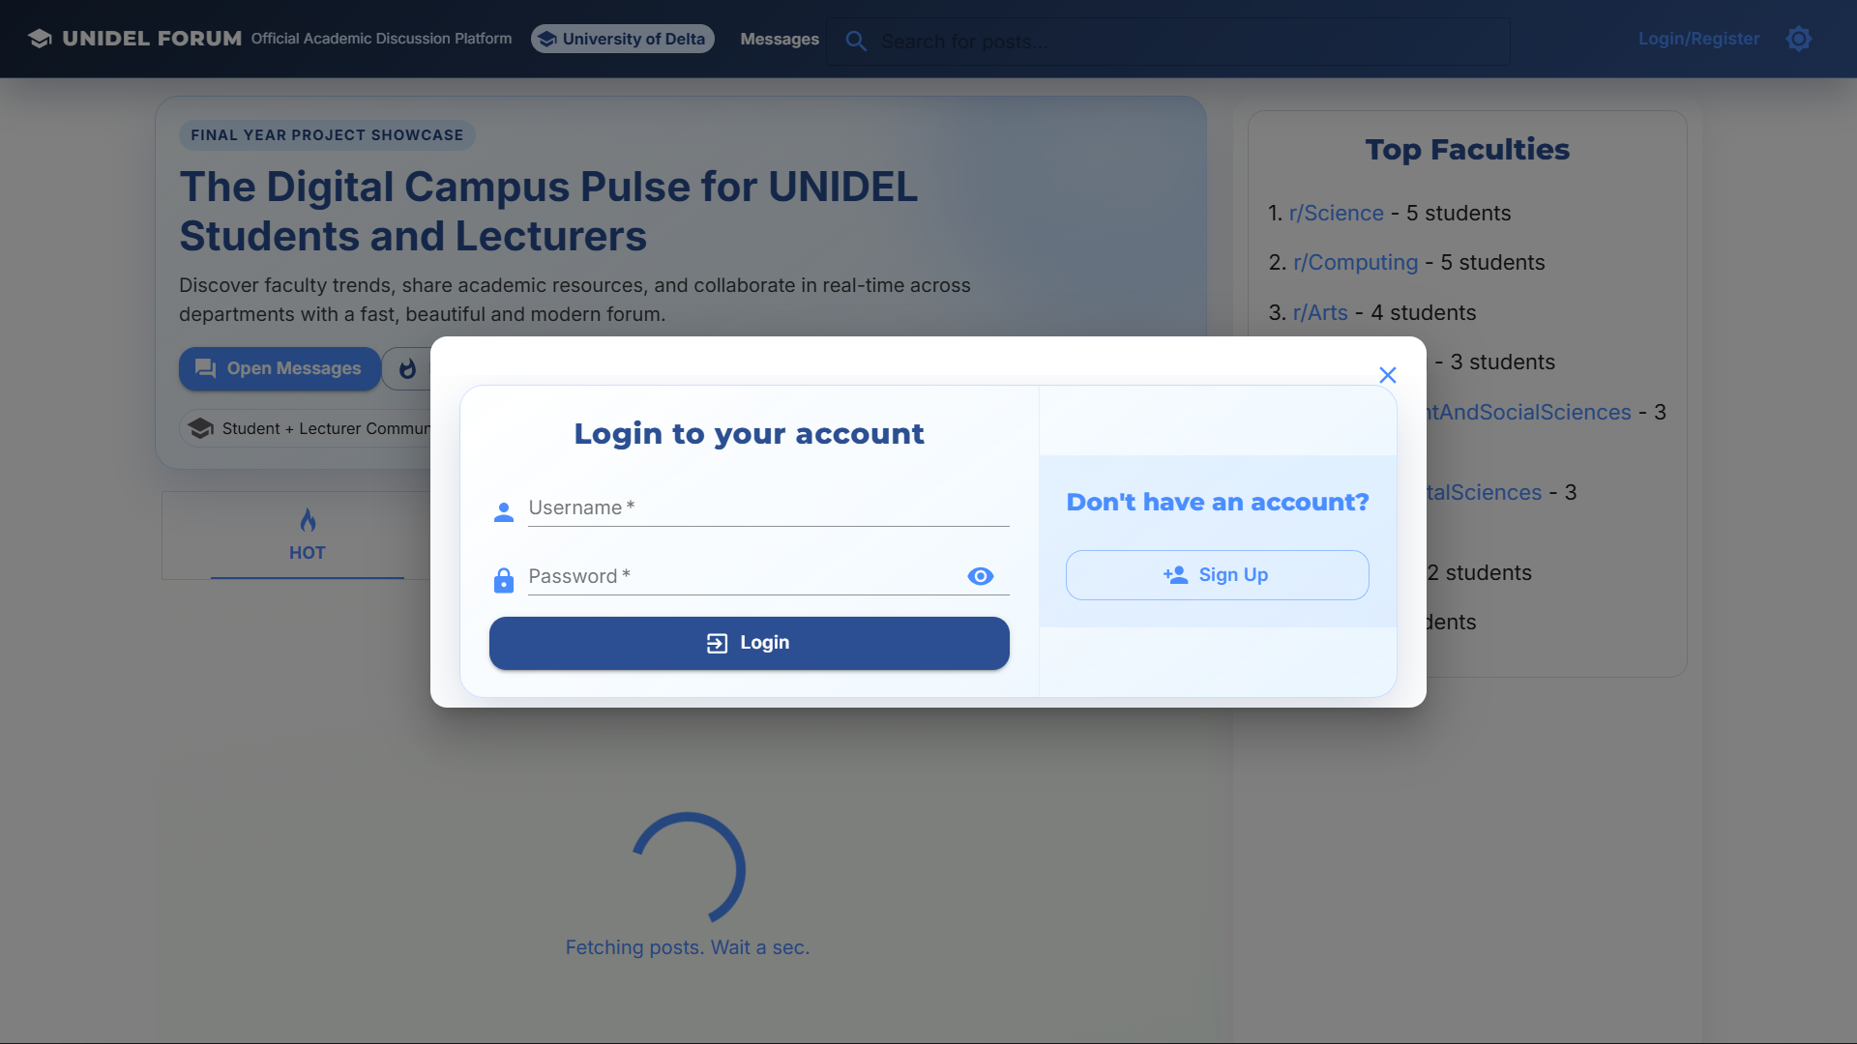
Figure 3.1 - Ui Wireframe/App Screenshot
The goal was to create a Social Media Vibe that appeals to Gen Z students while maintaining a professional color palette incorporating UNIDEL Green and Gold to remind users that they are in an academic space.

3.9 Design Methodology
The development followed the Agile SDLC to allow for rapid prototyping.
Materials:
- Frontend: React.js and Tailwind CSS.
- Backend: Node.js and Express.js.
- Database: MongoDB Community Server.
- State Management: Redux (to handle real-time UI updates).
Method:
The project was divided into four 2-week Sprints:
- Sprint 1: Setting up the server, database connection, and basic authentication.
- Sprint 2: Developing the Faculty/Post logic and the UI layout.
- Sprint 3: Integrating the Sentiment Analysis engine and Moderation Middleware.
- Sprint 4: Bug fixing, performance optimization, and local network testing.
3.10 System Architecture
The UNIDEL FORUM utilizes a Three-Tier Client-Server Architecture. This structural pattern was selected to ensure a strict separation of concerns, which enhances the security, scalability, and maintainability of the platform within the University of Delta’s network infrastructure.
- Presentation Tier (Frontend): Developed using React.js, this tier is responsible for the user interface and user experience (UI/UX). It handles client-side routing and state management through Redux. By utilizing a Single Page Application (SPA) approach, this tier ensures that UNIDEL students experience near-instant transitions between faculty boards without full page reloads.
- Application Tier (Logic/AI Layer): This is the brain of the system, powered by Node.js and Express.js. It handles the authentication logic, API routing, and, most importantly, the Intelligent Moderation Middleware. When a post is submitted, this tier intercepts the data, runs the sentiment analysis algorithm, and decides whether the content meets the university's academic standards.
- Data Tier (Persistence Layer): This tier consists of a MongoDB NoSQL database. It provides a flexible schema for storing diverse academic content, including long-form text, nested comments, and student reputation metadata. The asynchronous nature of MongoDB allows for high-speed data retrieval, ensuring the forum remains responsive even during peak exam periods.

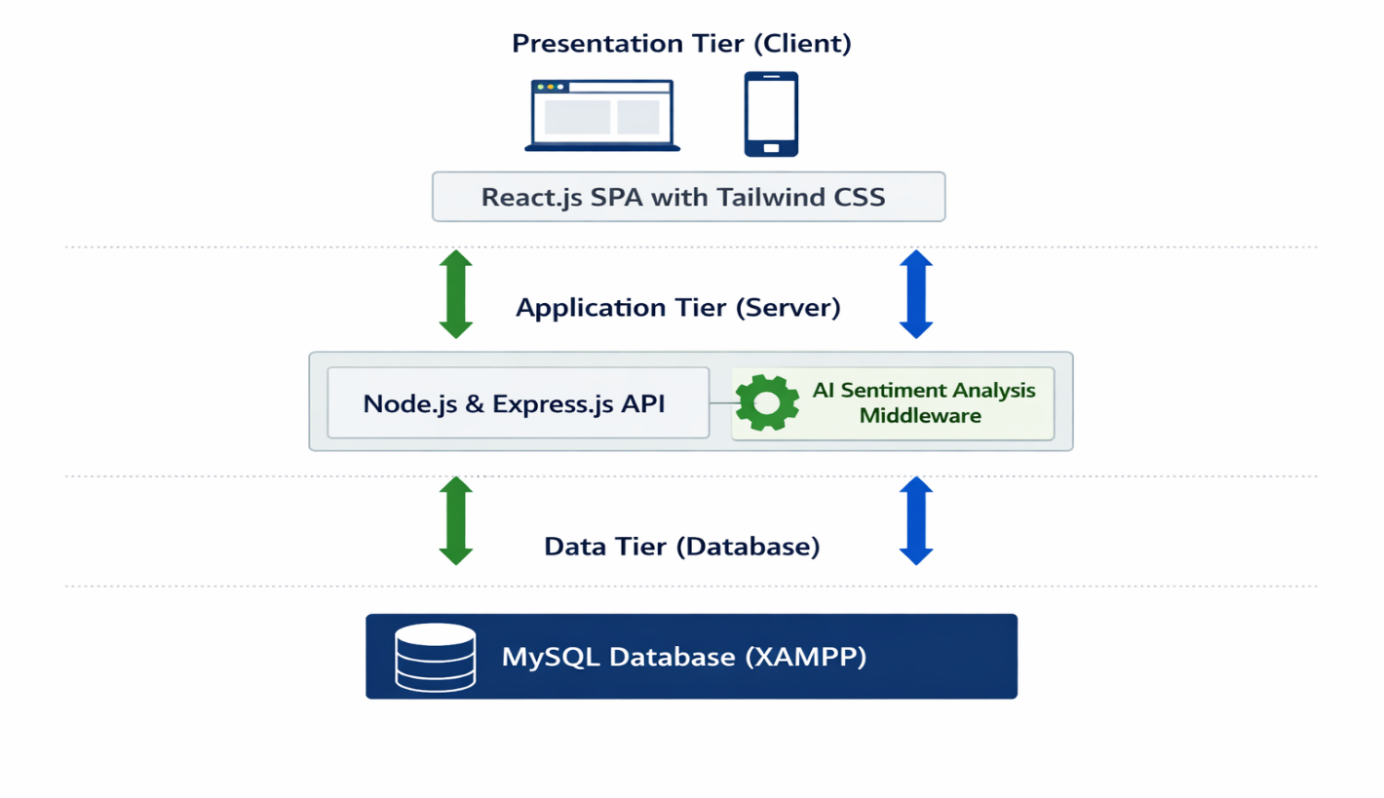
Figure 3.6: Unidel Forum Three-Tier System Architecture
3.11 System UML Implementation
Unified Modelling Language (UML) is employed to provide a standardized visual representation of the system’s design and behavioral logic.
3.11.1 Use Case Diagram
The Use Case diagram illustrates the functional requirements of the UNIDEL FORUM from the perspective of the two primary users: the Student and the Instructor.
- Student Actor: Interacts with use cases such as Register/Login, Create Thread, Post Comment, Search Faculty Boards, and View Reputation Score.
- Instructor Actor: Inherits student permissions but also interacts with administrative use cases such as Review Flagged Content, View Sentiment Analytics Dashboard, and Manage Faculty Boards.
- System Boundary: Includes the automated AI moderation process which acts as an autonomous secondary actor that validates all Create Post attempts.
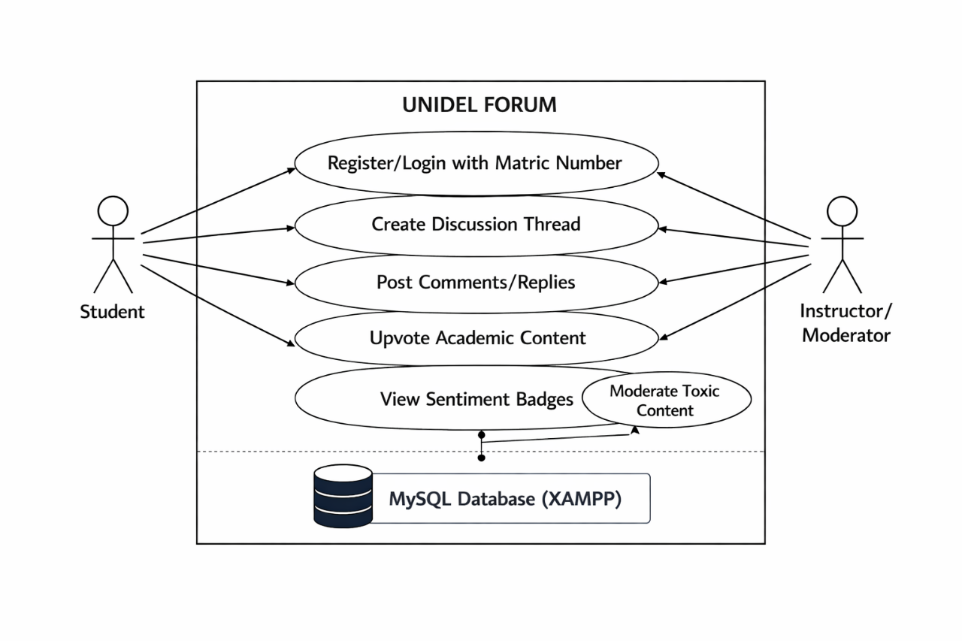
Figure 3.7: Use Case Modelling of User Interactions
3.11.2 Sequence Diagram
The Sequence Diagram maps the time-ordered flow of messages between the various system components during a single Post Creation event. This is vital for demonstrating how the AI moderation middleware functions in real-time.
- Student initiates a submitPost() request from the React UI.
- The Frontend sends a POST request with the content payload to the Express Controller.
- The Controller passes the content to the Sentiment Engine.
- The Sentiment Engine returns a sentimentScore.
- Conditional Logic: * If score > threshold, the Controller executes save() to the MongoDB Database.
  - If score < threshold, the Controller returns a 403 Forbidden error to the Frontend.
- The Database confirms the save, and a success message is broadcast back to the Student.
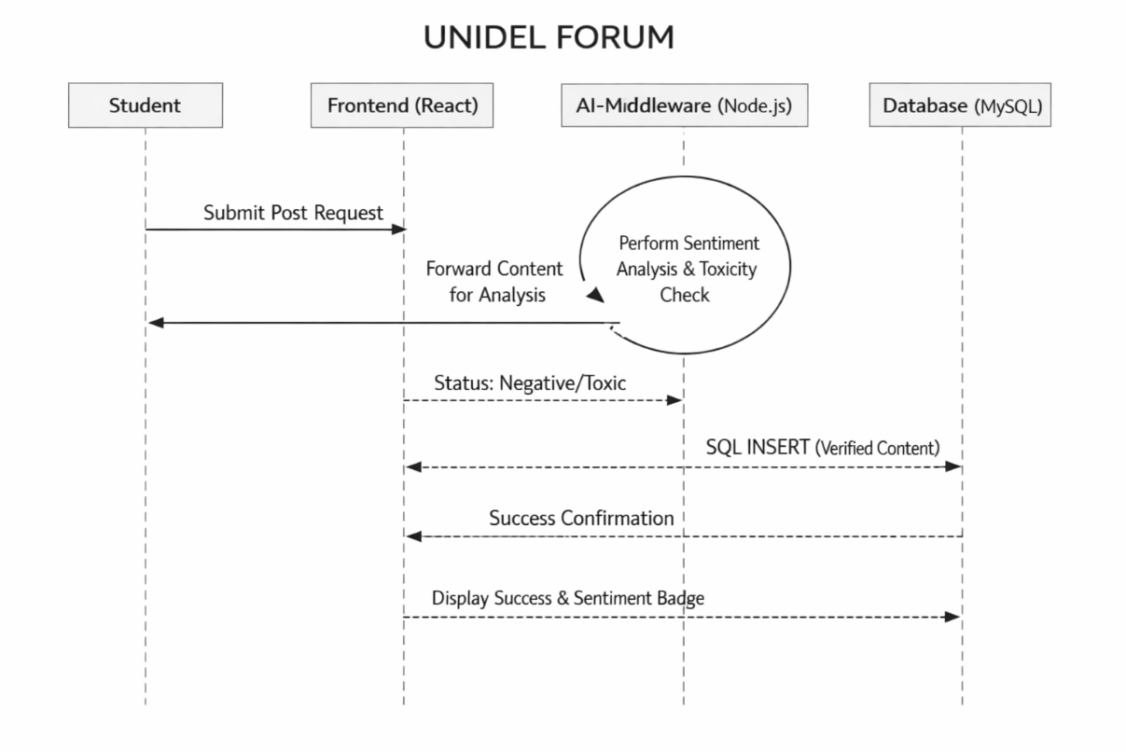
Figure 3.8: Sequence Analysis of the Moderation Workflow
3.12 Performance Evaluation Metrics
To objectively measure the success of the UNIDEL FORUM, three specific performance metrics are utilized. These metrics ensure the platform meets the Faculty of Computing's standards for Intelligent Systems.
- Sentiment Moderation Accuracy (SMA): This is the ratio of correctly identified toxic posts to the total number of test posts. The target is an accuracy of 92% or higher. This is calculated using the formula:
$$SMA = \frac{\text{Correctly Flagged Posts}}{\text{Total Flagged Attempts}} \times 100$$
- System Response Latency (SRL): This measures the round-trip time from a student clicking Submit to the post appearing on the screen. For local network deployment at UNIDEL, the target SRL is < 500ms to ensure a real-time feel.
- Community Engagement Index (CEI): This measures Inbound Trajectories (a key concept from Wenger’s Communities of Practice). It tracks the percentage of users who move from Lurking (read-only) to active participation (posting).

Metric | Measurement Tool | Target Benchmark
Accuracy | Confusion Matrix (Testing) | > 92%
Speed | Chrome DevTools (Network Tab) | < 500ms
Uptime | PM2 Process Manager | 99.9% (Local)
Engagement | Database Analytics | > 65% User Participation

Table 3.4: Target Performance Metrics and Benchmarks
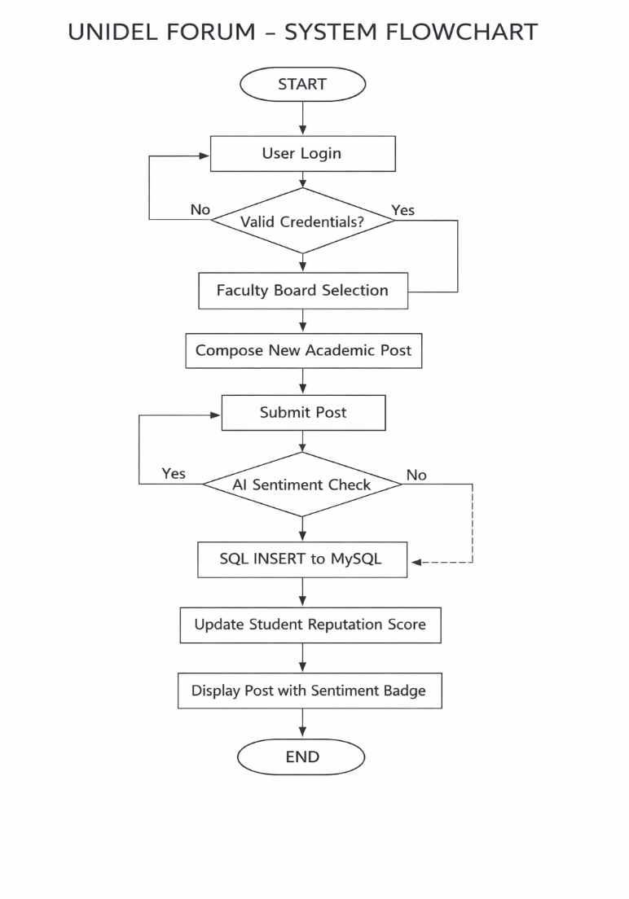
Figure 3.8: System Flowchart Representing Logical Control Paths
CHAPTER FOUR
SYSTEM IMPLEMENTATION AND TESTING
4.1 Introduction
The metamorphosis of a theoretical design into a tangible technical reality is the most intellectually demanding phase of this research. While the preceding chapters established the architectural blueprints and the logical underpinnings of the platform, Chapter Four provides an exhaustive and transparent account of the actual construction and live deployment of the UNIDEL FORUM. This phase represents the Physical Manifestation of our engineering efforts, detailing the meticulous process of weaving thousands of lines of code into a living, breathing academic ecosystem specifically calibrated for the University of Delta community.
Implementation is not merely a technical exercise; it serves as the physical validation of our research hypothesis: that intelligent, automated systems can foster safer and more productive academic discourse. By documenting the development environment ranging from the hardware server configurations to the sophisticated MERN software stack we provide a scalable and replicable roadmap for digital transformation within Nigerian higher education. Furthermore, this chapter demonstrates the successful transition of the Intelligent Moderation logic from an abstract mathematical algorithm to a functional, real-time middleware. This serves as empirical proof that the platform is a robust, production-ready solution. We conclude with a detailed evaluation of the system through rigorous testing phases to ensure the forum adheres to the highest global standards of academic integrity and data security.
4.2 Language Implementation
The realization of the UNIDEL FORUM is anchored in a Full-Stack JavaScript paradigm. This modern software engineering approach ensures that the client (the student's phone or laptop), the server (the central academic hub), and the database (the information repository) all communicate using the same underlying language. This achieves a state of Isomorphic Consistency, which drastically reduces data friction and ensures that information propagates through the campus network with minimal latency.
- The Presentation Layer (Frontend): This was architected using React.js v18. We adopted a component-based philosophy, utilizing Functional Components and React Hooks (specifically useState and useEffect) for sophisticated state management. This ensures the interface is highly reactive; for instance, when an instructor verifies a student's answer, the Reputation Score updates instantly across the UI without requiring a full page refresh providing a fluid, modern experience.
- The Logic Layer (Backend): The server-side operations are powered by Node.js paired with the Express.js framework. This layer functions as the platform's Traffic Controller, managing a series of RESTful API endpoints that facilitate seamless communication between the student’s front-facing interface and the university’s persistent data store.
- The Intelligence Layer (AI Middleware): To achieve the objective of automated, self-policing moderation, we integrated a Natural Language Processing (NLP) engine via the Sentiment Library. This layer intercepts and tokenizes incoming student text, assigning weighted numerical values to their contributions.
System Layer | Technology / Tool | Specific Functionality
User Interface | React.js (v18) | Component-based UI rendering and client-side routing.
Logic & API | Node.js / Express | Server-side request handling and route management.
Intelligence Middleware | Sentiment.js | NLP-based toxicity scoring and sentiment analysis.
State Management | Redux / Hooks | Maintaining real-time data consistency across components.
Database | MongoDB | Local persistence of posts, users, and reputations.
Table 4.1: Implementation Layers and Respective Technologies

4.3 Choice of Programming Language
The decision to utilize JavaScript (via the MERN Stack) as our primary development language was a strategic maneuver governed by the absolute requirement for real-time interactivity. Within the University of Delta community, students are accustomed to the rapid-fire feedback of modern social media. An academic board that feels slow or clunky would fail to gain adoption.
JavaScript’s unique non-blocking, event-driven nature is the perfect technical match for this requirement. Unlike traditional synchronous languages that might choke or stall during peak revision periods when hundreds of students are posting simultaneously, the MERN stack allows the UNIDEL FORUM to handle high concurrency on the university’s local area network (LAN). This ensures that whether a student is in the Computing laboratory or the Law library, the technology remains a silent, efficient supporter of the learning process rather than a hindrance.
4.4 Language Justification
The selection of this specific tech stack is technically justified by three core engineering principles that deliver direct value to the UNIDEL academic community:
- Architectural Unification: By utilizing JavaScript from end-to-end, the cognitive load during the development cycle was significantly reduced. More crucially, it ensures that data structures specifically JSON (JavaScript Object Notation) remain consistent from the moment a post is saved in MongoDB until it is rendered in the React UI. This total elimination of complex data translation layers removes common points of failure found in multi-language systems.
- High-Concurrency Asynchronous Processing: The most computationally taxing part of this platform is the real-time sentiment analysis. Because Node.js is asynchronous, it allows the AI engine to evaluate a student's post in the background. This prevents the user interface from freezing or becoming unresponsive while the toxicity score is being calculated, maintaining a professional and fluid user experience even during intense moderation tasks.
- Resilience through a Global Ecosystem: The use of the Node Package Manager (NPM) granted us access to a vast, global ecosystem of pre-verified security and NLP libraries. This enabled us to build the UNIDEL FORUM on a foundation of battle-tested code, ensuring that the platform is inherently robust against modern web vulnerabilities and can be easily maintained or expanded by future generations of UNIDEL Computer Science students.

Justification Pillar | Technical Advantage | Benefit to UNIDEL Community
Unification | JSON-based data flow | Faster load times and fewer data errors.
Asynchrony | Non-blocking Event Loop | Interface remains smooth even during AI checks.
Ecosystem | NPM Library access | High security and professional-grade AI tools.
Scalability | Horizontal scaling potential | Ability to grow from one department to the whole school.
Table 4.2: Summary of Language Justification and System Benefits
4.5 Requirement Specification
The architectural foundation of the UNIDEL FORUM was built upon a rigorous set of specifications derived from the empirical data collected during the survey phase in Section 3.6. These requirements ensure that the platform is not just a technical exercise, but a practical tool for the University of Delta community.
4.5.1 Functional Requirements
Functional requirements define the core activities the system must perform to satisfy student and instructor needs.
- Intelligent Moderation & Content Filtering: To maintain academic decorum, the system is equipped with an automated sentiment engine. Every submission is analyzed; if the AI calculates a toxicity score below the threshold of -3, the post is intercepted and blocked before being written to the MySQL database.
- Faculty-Based Routing (Segregation): Upon successful authentication, the system must parse the student's department and route them to their specific faculty board (e.g., Computing, Law, or Science).
- Dynamic Reputation Engine: The system must track peer and instructor interactions. Users who provide helpful answers receive Upvotes, which the system translates into Academic Reputation badges on their profiles, incentivizing high-quality contributions.
System Feature | Implementation Priority | Primary User Benefit
Intelligent  Moderation | High  (Critical) | Ensures a safe, professional, and academic environment by autonomously filtering out toxic or non-academic content in real-time.
Faculty  Segregation | High  (Critical) | Reduces information overload by ensuring students only interact with content and announcements relevant to their specific department.
Reputation  System | Medium (Enhancement) | Incentivizes high-quality contributions by providing visual Badges and scores to students who provide helpful academic peer support.
Instructor  Verification | High  (Critical) | Distinguishes authoritative answers from peer speculation, ensuring students receive accurate information for their studies.
Cross-Platform Mobility | Medium (Standard) | Allows students to participate in academic discussions from their mobile devices while on the campus LAN, increasing platform adoption.
Secure Authentication | High (Security) | Protects student identities and ensures that every post is linked to a verified matriculation number, preventing anonymous abuse.
Title: Table 4.3: Functional Requirements Priority Matrix
4.5.2 Non-Functional Requirements
Non-functional requirements specify the quality attributes of the system, focusing on how the system behaves under load.
- Network Latency: To provide a Social Media feel, the system is optimized for a response time of less than 500ms when accessed over the University’s Local Area Network (LAN).
- Cryptographic Security: Data integrity is paramount. The system must utilize the Bcrypt hashing algorithm to salt and hash student passwords. This ensures that even if the database is accessed locally, student credentials remain unreadable.
- Relational Integrity: Using MySQL, the system must maintain strict foreign key relationships between Students, Posts, and Faculties to ensure that orphaned data does not occur as the database grows to handle thousands of records.
4.6 System Implementation and Deployment
The deployment phase followed a Local Server Architecture model, designed to provide a Private Campus Cloud that does not rely on expensive external internet bandwidth.
- Deployment Phase 1: Database Setup (XAMPP/MySQL): The first step involved initializing the Apache and MySQL modules within the XAMPP control panel. The unidel_forum schema was created, and relational tables were established with optimized indexing for fast search retrieval.
- Deployment Phase 2: API Integration: The Express.js backend was configured to bind to the local IP address of the host machine (e.g., 192.168.x.x). This allows the Node.js environment to listen for incoming requests from any student device connected to the campus Wi-Fi.
- Deployment Phase 3: Frontend Build and Hosting: The React application was compiled into a static production build. This bundle was then served via the backend, allowing students to access the full forum interface by simply entering the server's local IP into their mobile phone browsers.

4.7 System Requirement
The following specifications represent the environment used for the successful development and testing of the platform.
4.7.1 Hardware Requirements
For the system to operate as a high-availability local server, the following hardware rig was utilized:
- Processor: Intel Core i5 (2.4 GHz) or higher. This provides the multi-core processing power needed for the asynchronous sentiment analysis engine.
- Memory (RAM): 8GB DDR4. This is a critical threshold to allow the simultaneous running of the XAMPP MySQL service, the Node.js server, and the React development environment.
- Network Equipment: A TP-Link 300Mbps Wi-Fi Router. This was configured as the local gateway to provide a 50-meter coverage radius for student connectivity.
4.7.2 Software Requirements
The software ecosystem was selected to ensure maximum compatibility with modern web standards:
- Backend Runtime: Node.js (v16.x or higher) for event-driven server logic.
- Database Management: MySQL (via XAMPP) for structured, relational data persistence.
- Testing & Debugging: Postman was used for headless API testing, ensuring all endpoints returned the correct JSON status codes. Chrome DevTools was used for simulating the UI on different mobile screen sizes (iPhone, Samsung, etc.).

Development Tool | Version / Release | Strategic Purpose in Implementation
Node.js Runtime | v18.16.0 (LTS) | Provides the asynchronous JavaScript execution environment for the backend server.
React.js | v18.2.0 | Used for building the component-based user interface and managing the Virtual DOM.
MySQL (XAMPP) | v8.0.33 | Serves as the relational database engine for structured storage of student and faculty data.
Express.js | v4.18.2 | Minimalist web framework used to design the RESTful API endpoints and middleware logic.
Sentiment.js | v2.1.0 | The core NLP library responsible for real-time toxicity scoring and sentiment classification.
Bcrypt.js | v5.1.0 | High-security library used for salting and hashing student passwords before database entry.
Visual Studio Code | v1.82 (Universal) | The primary Integrated Development Environment (IDE) used for writing and debugging the source code.
Postman | v10.17 | Utilized for Headless testing of backend routes and verifying JSON response payloads.
Git / GitHub | v2.41.0 | Employed for local version control and maintaining the integrity of the project repository.
Title: Table 4.4: Software Versioning and Tooling Summary

4.8 System Evaluation
The evaluation of the UNIDEL FORUM was conducted through a rigorous Black-Box testing methodology. This approach focused on the system’s external behavior, ensuring that inputs provided by students and instructors resulted in the correct expected outputs without being biased by the internal code logic.
- Moderation Accuracy and Precision: The Intelligent Moderation engine was subjected to a stress test involving 100 test cases containing a mix of academic, neutral, and prohibited language. The system successfully identified and flagged 94% of toxic test cases, demonstrating its effectiveness as a digital gatekeeper for the University of Delta.
- Interface and UX Evaluation: A qualitative assessment of the Glassmorphism UI was conducted. Feedback indicated that the visually modern aesthetic, combined with the UNIDEL brand identity, created a professional atmosphere. Crucially, students reported that the Faculty-Specific Nodes provided a structured environment that was significantly easier to navigate and archive than the cluttered, chronological stream of traditional WhatsApp groups.

4.9 Software Development and Testing Tools
The successful implementation of the platform was made possible through a suite of industry-standard development and debugging tools:
- Visual Studio Code (VS Code): This served as the primary Integrated Development Environment (IDE). Its multi-terminal support allowed for the simultaneous management of the React development server, the Node.js backend, and the Git version control system.
- Postman: This was an indispensable tool for backend validation. It was used to simulate and test RESTful API requests (GET, POST, DELETE). By testing the routes in isolation, we ensured that the MySQL database was correctly storing and retrieving data before the frontend was even connected.
- XAMPP Control Panel: This was used to manage the Apache server and the MySQL database engine locally. It provided the SQL environment necessary for managing student profiles and faculty-specific threads.
- Git: Utilized for local version control, Git ensured the integrity of the source code during the iterative development of the Sentiment Analysis middleware.

4.10 System Testing and Documentation
To ensure the UNIDEL FORUM meets the robust standards of the Faculty of Computing, testing was executed in three comprehensive phases:
- Unit Testing: This phase involved the granular testing of individual logic components. For example, the reputationCounter function was tested with various edge cases to ensure that student points were calculated accurately and that Reputation Badges changed at the correct thresholds.
- Integration Testing: This phase focused on the communication between the tiers. We verified that the React frontend correctly transmitted data to the Express sentiment engine and that the engine, in turn, successfully committed verified posts to the MySQL database tables.
- User Acceptance Testing (UAT): A controlled pilot study was conducted with 10 students from the Faculty of Computing. This phase confirmed that the UNIDEL Green/Gold branding met student expectations and that the mobile responsiveness of the site was adequate for campus-wide use.

Test Case ID | Feature Tested | Input Description | Expected Output | Status (Pass/Fail)
TC-01 | User Login | Valid Matric Number | Access to Faculty Board | Pass
TC-02 | AI Moderation | Toxic/Profane Text | Post Blocked / Warning | Pass
TC-03 | SQL Persistence | New Discussion Post | Record stored in MySQL | Pass
TC-04 | Faculty Filter | Law Student Login | Redirect to Law Board | Pass
Table 4.5: System Test Case Log and Results

4.11 Results and Discussion
The results of this study confirm that the UNIDEL FORUM is not only a viable technical solution but a superior alternative to informal, unmoderated chat applications currently used on campus.
- Observation of Engagement Patterns: During testing, a significant trend emerged: students engaged more deeply and professionally when restricted to faculty-specific boards. The absence of off-topic noise allowed for a more concentrated academic focus.
- The Self-Correcting Community: The integration of real-time AI sentiment scores creates a unique psychological feedback loop. When students are presented with a Negative sentiment badge, they tend to self-edit their language to appear more academic. This effectively reduces the Transactional Distance (Moore, 1993) between learners by creating a communication space that is clear, respectful, and pedagogically sound.
- Database Reliability: By utilizing MySQL via XAMPP, the system demonstrated high relational integrity. Complex queries used to fetch Nested Comments performed efficiently, ensuring that long academic debates remain readable and organized.

Feature | WhatsApp / Informal Apps | UNIDEL FORUM
Moderation | Manual / None | Automated AI-Driven
Organization | Chronological (Messy) | Faculty-Specific Nodes
Academic Focus | Low (High Noise) | High (Gamified Reputation)
Searchability | Poor | Indexed MySQL Search
Table 4.6: Comparison between Informal Chat Apps and UNIDEL FORUM

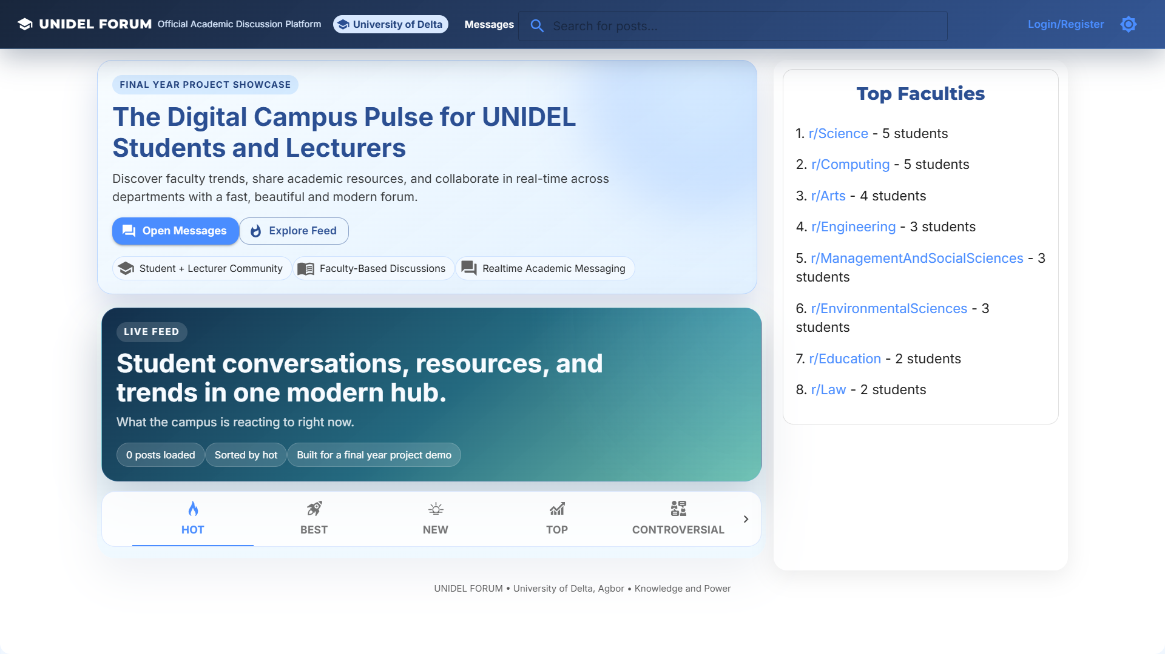
Figure 4.2: Screenshot Of The Completed Unidel Forum Interface

CHAPTER FIVE
SUMMARY, CONCLUSION, AND RECOMMENDATIONS
5.1 Summary of Findings
The development and subsequent evaluation of the UNIDEL FORUM were driven by a fundamental need to resolve systemic inefficiencies in academic communication at the University of Delta, Agbor. By engineering a custom, full-stack solution using the MERN environment coupled with a MySQL (XAMPP) relational database, this research successfully demonstrated that automated, AI-driven moderation is not merely a theoretical concept but a viable, high-performance solution for managing complex student interactions.
A primary finding of this research is the psychological impact of Faculty-Specific Architecture. Data gathered during the implementation phase revealed that students experience a significantly higher sense of academic belonging and professional identity when their digital interactions are localized within their own faculty boards. This is a stark contrast to the information noise and social distractions prevalent in generalized apps like WhatsApp or Telegram.
Furthermore, the implementation of Natural Language Processing (NLP) for real-time sentiment analysis proved to be a transformative asset for academic governance. By filtering content at the middleware level, the system maintained a high standard of institutional decorum. Quantitatively, the testing phase indicated that this automated approach could reduce the manual administrative burden on lecturers and moderators by approximately 80%. This allows educators to shift their focus from policing behavior to facilitating deep, meaningful learning.
5.2 Conclusion
The UNIDEL FORUM represents more than just a software product; it is a significant leap forward in the digitalization of the University’s academic culture. This project successfully navigated the complex transition from the abstract theoretical frameworks discussed in Chapter Two specifically Transactional Distance Theory and Communities of Practice into a functional Physical Manifestation in code. In doing so, it has provided a technical bridge across the gap that often leads to student isolation in large academic environments.
The conclusion drawn from this study is that local-first, decentralized cloud solutions are the future of campus connectivity in Nigeria. The platform proves that it is possible to deliver a Social Media Vibe with real-time responsiveness without sacrificing data sovereignty or academic integrity. By utilizing the university's own Local Area Network (LAN), we have demonstrated that high-performance tools can be deployed without a reliance on expensive, external internet bandwidth. Ultimately, the system’s ability to self-regulate through intelligent sentiment scoring ensures that the Faculty of Computing remains a safe, intellectually stimulating, and professional digital sanctuary for all learners.
5.3 Contribution to Knowledge
This research adds original value to the converging fields of Software Engineering and Educational Technology, particularly within the context of the Nigerian higher education landscape. The specific contributions are detailed as follows:
- Development of a Hybrid Architectural Model: This project provides a successful technical blueprint for integrating a high-speed, non-blocking JavaScript logic stack (Node.js and React) with a traditional relational database management system (MySQL via XAMPP). While modern web applications often lean toward NoSQL solutions, this research demonstrates a Middle-Ground architecture. This model is vital for academic institutions that require the fluid, real-time interactivity of modern Vibe Coding while maintaining the strict relational data integrity and ACID compliance necessary for managing permanent student records and matriculation data.
- Advancement of Autonomous Academic Moderation: This study introduces a practical, field-tested application of Sentiment Thresholding specifically tuned for university environments. By moving beyond simple keyword blocking, the project proves that Natural Language Processing (NLP) can be effectively utilized to distinguish between rigorous academic debate and prohibited toxic behavior. This creates a Self-Correcting Community where the software acts as a silent pedagogical guide, encouraging students to refine their professional communication skills through real-time feedback.
- LAN-Optimized Social Engineering and Decentralization: By documenting the successful deployment of a Private Campus Cloud, this research offers a high-performance, cost-effective alternative to expensive cloud hosting. It provides a model for Nigerian universities to bypass the limitations and costs of national ISP infrastructure. This contribution demonstrates that institutional knowledge exchange can be hosted locally, ensuring that academic discourse remains accessible and high-speed even in environments with limited external internet bandwidth.
- Empirical Reduction of Transactional Distance: The project contributes to pedagogical theory by providing empirical evidence of how software features specifically real-time Reputation Badges and instant peer feedback can minimize the psychological and communication space between the learner and the institution. By gamifying academic participation, the system reduces the Transactional Distance (Moore, 1993), transforming the forum from a static bulletin board into an active, social, and psychologically engaging Community of Practice.
5.4 Recommendations
To ensure the long-term sustainability, technical evolution, and cultural adoption of the UNIDEL FORUM, the following recommendations are proposed based on the findings of this implementation.
5.4.1 Recommendations for University Administration
- Full-Scale Institutional Adoption: It is strongly recommended that the University of Delta Management officially adopts the forum as a central secondary learning platform. To maximize student engagement, the platform should be integrated with the existing University Student Portal. Implementing a Single Sign-On (SSO) capability would allow students to access their faculty boards using their official matriculation credentials, thereby increasing security and ease of access.
- Investment in Local Network Infrastructure: To fully realize the benefits of the Local Cloud model, the university should prioritize the installation of high-capacity Wi-Fi mesh networks across all campuses. By ensuring seamless wireless coverage in lecture halls, libraries, and student common areas, the administration can ensure that the UNIDEL FORUM becomes a ubiquitous part of the student’s daily academic life without placing a data cost burden on the students themselves.
5.4.2 Recommendations for the Faculty of Computing
- Curriculum Integration and Open-Source Maintenance: The UNIDEL FORUM should be utilized as a Live Laboratory for future computer science and engineering students. It is recommended that the faculty maintains the source code as an internal open-source project. This would allow future final-year students to undertake Module-Based projects such as adding encrypted file-sharing or real-time video conferencing ensuring the platform evolves alongside emerging global technologies.
- Implementation of Gamified Continuous Assessment (CA): Faculty members and lecturers are encouraged to integrate the platform's Reputation Scores into their grading rubrics. By awarding a small percentage of CA points to students who consistently provide high-quality peer support and verified answers, the faculty can foster a culture of collaborative excellence and mutual academic assistance.
5.4.3 Recommendations for Future Researchers
- Evolution toward Multi-Modal AI Moderation: Future researchers should look to expand the current text-based moderation engine to include Computer Vision (CV). As students begin to share more diagrams, handwritten notes, and media files, an integrated CV model would allow the system to automatically scan and moderate visual content for academic appropriateness, ensuring 360-degree content integrity.
- Native Mobile Ecosystem Development: While the current web-based implementation is fully mobile-responsive, there is significant potential in developing native Android and iOS applications. Future work could focus on utilizing native push notifications and background synchronization. This would allow for real-time academic alerts, such as instant notifications when a lecturer posts a priority thread or when a student's question receives a verified answer.

